Name : Siddiqui Umar Farooque
Roll No. : 21CO57
Batch 4
Course: SE

Assignment No. 01

Aim : To develop an architectural design and mention the types of coupling and cohesion.

Theory :

IEEE defines architectural design as “the process of defining a collection of hardware and software components and their interfaces to establish the framework for the development of a computer system.” The software that is built for computer-based systems can exhibit one of these many architectural styles. Each style will describe a system category that consists of: A set of components (e.g.: a database, computational modules) that will perform a function required by the system. The set of connectors will help in coordination, communication, and cooperation between the components. Conditions that how components can be integrated to form the system. Semantic models that help the designer to understand the overall properties of the system. Coupling: Coupling is the measure of the degree of interdependence between the modules. A good software will have low coupling.

Types of Coupling :

- Data Coupling : If the dependency between the modules is based on the fact that they communicate by passing only data, then the modules are said to be data coupled. In data coupling, the components are independent of each other and communicate through data. Module communications don‟t contain tramp data. Example - customer billing system. Software Engineering Lab Stamp coupling: In stamp coupling, the complete data structure is passed from one module to another module. Therefore, it involves tramp data. It may be necessary due to efficiency factors- this choice was made by the insightful designer, not a lazy programmer.

- Control Coupling : If the modules communicate by passing control information, then they are said to be control coupled. It can be bad if parameters indicate completely different behavior and good if parameters allow factoring and reuse of functionality. Example - sort function that takes comparison function as an argument.

- External Coupling : In external coupling, the modules depend on other modules, external to the software being developed or to a particular type of hardware. Ex- protocol, external file, device format, etc.

- Common Coupling: The modules have shared data such as global data structures. The changes in global data mean tracing back to all modules which access that data to evaluate the effect of the change. So it has disadvantages like difficulty in reusing modules, reduced ability to control data accesses, and reduced maintainability.

- Content Coupling : In a content coupling, one module can modify the data of another module, or control flow is passed from one module to the other module. This is the worst form of coupling and should be avoided.

Cohesion :

Cohesion is a measure of the degree to which the elements of the module are functionally related. It is the degree to which all elements directed towards performing a single task are contained in the component.

Types of Cohesion :

- Functional Cohesion : Every essential element for a single computation is contained in the component. A functional cohesion performs the task and functions. It is an ideal situation.

- Sequential Cohesion : An element outputs some data that becomes the input for another element, i.e., data flow between the parts. It occurs naturally in functional programming languages.

- Communicational Cohesion : Two elements operate on the same input data or contribute towards the same output data. Example- update record in the database and send it to the printer.

- Procedural Cohesion : Elements of procedural cohesion ensure the order of execution. Actions are still weakly connected and unlikely to be reusable. Ex : calculate student GPA, print student record, calculate cumulative GPA, print cumulative GPA.

- Temporal Cohesion : The elements are related by their timing involved. A module connected with temporal cohesion all the tasks must be executed in the same time span. This cohesion contains the code for initializing all the parts of the system. Lots of different activities occur, all at unit time.

- Logical Cohesion : The elements are logically related and not functionally. Ex- A component reads inputs from tape, disk, and network. All the code for these functions is in the same component. Operations are related, but the functions are significantly different.

- Coincidental Cohesion : The elements are not related (unrelated). The elements have no conceptual relationship other than location in source code. Ex - print the next line and reverse the characters of a string in a single component.

Architecture for our content-based Social Media App :

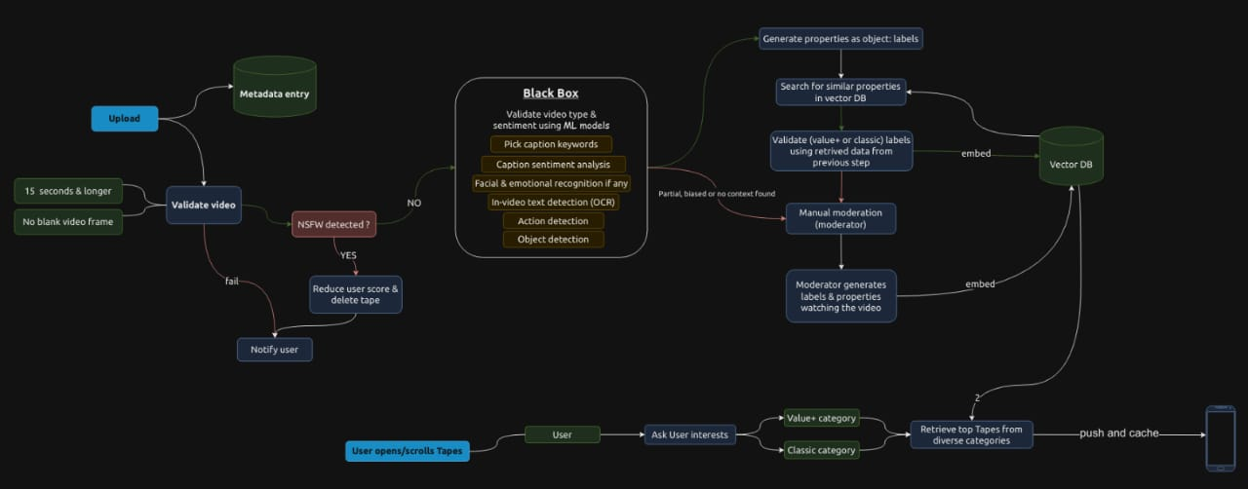

Examples of cohesion in social media app :

- The user profile module is cohesive because it contains all the information related to a user, such as their name, bio, profile picture, and posts.
- The feed module is cohesive because it displays a list of posts from the user's friends and followed accounts.
- The messaging module is cohesive because it allows users to send and receive messages from each other.

Examples of coupling in social media apps :

- The user profile module is coupled to the news feed module because the feed module displays posts from the user's friends.
- The messaging module is coupled to the user profile module because the messaging module allows users to send messages to other users.
- The feed module is coupled to the content creation module because the news feed module displays posts that have been created by users.
- In general, high cohesion is desirable in software design because it makes modules easier to understand and maintain. Low coupling is also desirable because it makes modules more independent and less likely to be affected by changes in other modules.

In the context of social media apps, cohesion is important because it allows users to easily find and interact with the information and features that they are looking for. Coupling is also important because it allows different modules of the app to work together seamlessly.

For example, the high cohesion of the user profile module makes it easy for users to find all of the information related to a particular user. The low coupling of the messaging module makes it possible for the messaging module to be used independently of the other modules in the app.

By carefully considering the trade-offs between cohesion and coupling, software developers can create social media apps that are both easy to use and maintain.

